

|  |
| --- |
|  |
| Content Manager Training Guide  Scope: Guide for Managers on how to manage content and permissions  Project Manager: Jack Boocock  Author: Irimie Razvan |



Zedra External Collaboration  
Platform

Version: 1.0

Date: 09.2.2020

#### ABOUT THIS DOCUMENT

* 1. **Document control:**

|  |  |  |  |
| --- | --- | --- | --- |
| Version | Date | Changed By | Purpose of revision |
| 1.0 | 09.25.2020 | Razvan Irimie | Created Document |
|  |  |  |  |
|  |  |  |  |

* 1. **About:**

The Zedra External Collaboration Platform is a solution based on **SharePoint Online** which allows users to easily collaborate on documents and content with Zedra Staff. Users can upload, share and manage content and documents using in a familiar and intuitive manner.

* 1. **Objective:**

The objective of this document is:

* To provide appropriate training and guidance for Content Managers on how to manage content and access for external and internal users to the **External Collaboration Platform**

#### MANAGE ACCESS

* + Open **Microsoft Teams**, navigate to the “**Group – External Collaboration**” **Team** and then select the appropriate **Office** channel, from the list (**Zedra** **Office** in the example below).

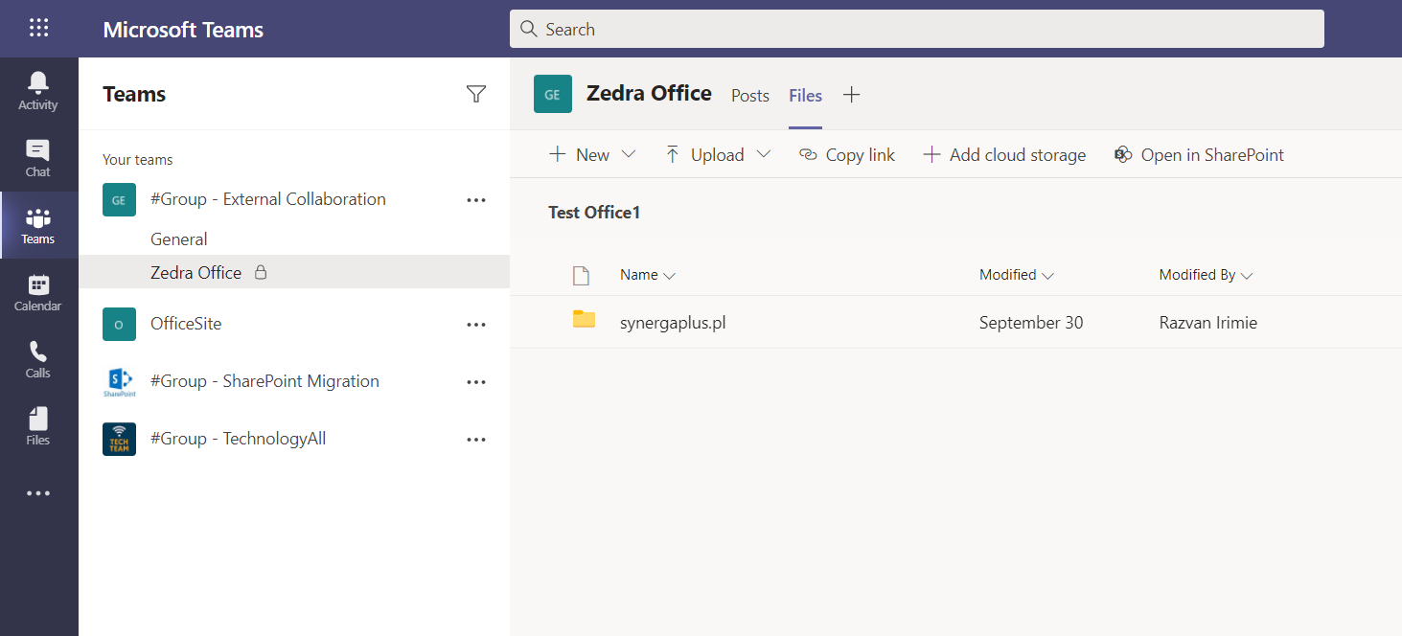**! Note**: Zedra Staff and external users will be able to collaborate using the **SharePoint Online** **Site** associated with the **Teams** **Channel** (Zedra Office).

* + Click on **Open in SharePoint** link, afterwards you will be redirected to the **External Collaboration SharePoint Online Site.**
  + 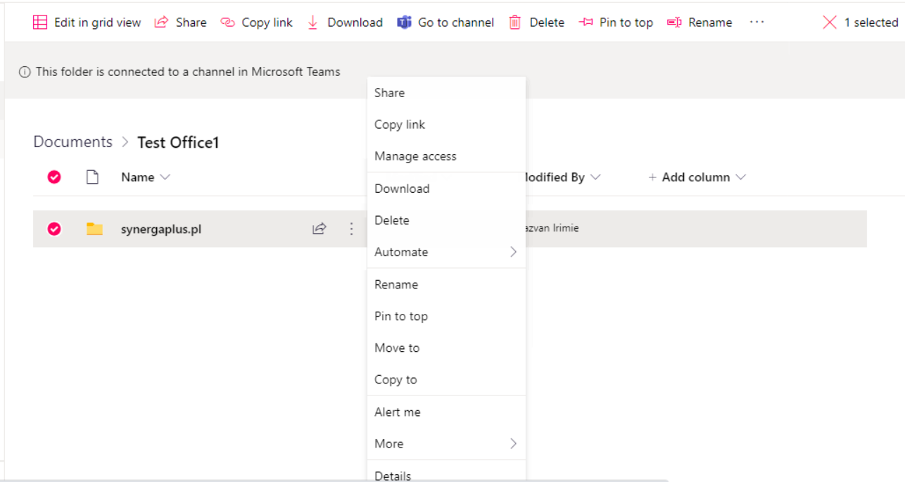From here you can **Manage Access** to the client folder, by selecting the **ellipses** and “**Manage** **Access”** option from the drop-down menu
  + The “**Manage** **Access**” pane displayed on the left-hand side of the page will allow content managers to add or remove users as well as to grant specific permissions (Read, Write, Owner, etc.)

##### **Grant Permissions via Link:**

* 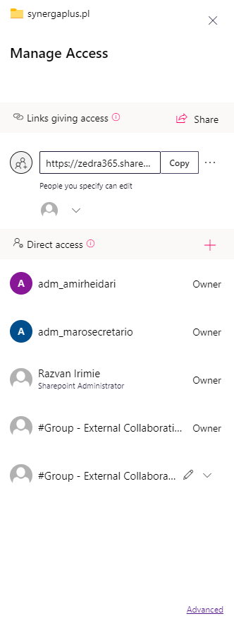Managers can grant access to other users by using the “**Share**” button:

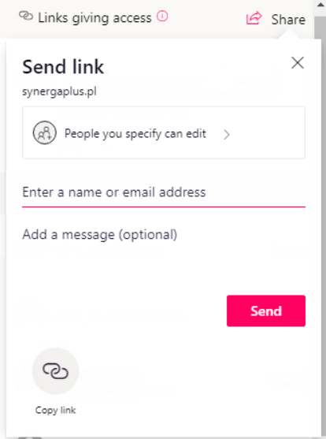

* By default, the link grants **edit** **permissions** to invited users. Clicking on the “**People you specify can edit**” link, offers more granular control over permissions.
* **Content Managers** can change who can access the link and whether people can edit the shared folder, by unchecking the “**Allow Editing”** option.
* **Options** for **Who would you like this link to work for:**

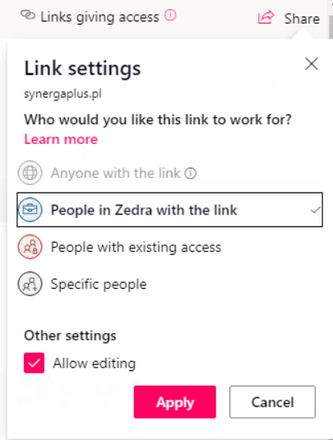

People in “Zedra” with this link option: gives anyone in your organization who has the link access to the file, whether they receive it directly from you or forwarded from someone else.

People with existing access can be used by people who already have access to the document or folder. Use this if you just want to send a link to somebody who already has access.

Specific people option, provides access only to the people you specify.

* + After all the permissions have been modified accordingly, select **Apply** to save the changes
  + Enter the name or **email** **address**, (optionally) a **welcome** **message** for the **user** and select **Send**. (The user will receive an email invite to the specific folder).

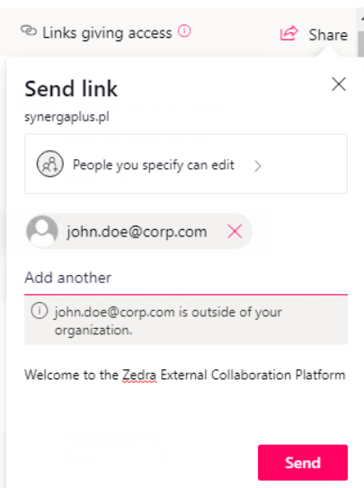

**! Note**: If people forward the sharing invitation, only people who already have access to the item will be able to use the link.

* + After the link has been sent using the steps above, the invited user will appear under the **This Link works For**

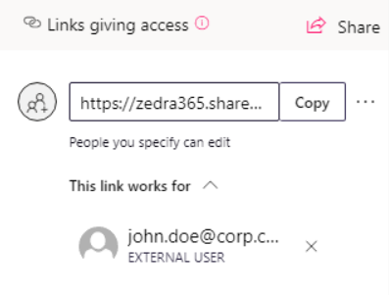

* + External users can be removed by clicking on the **X** link next to the users email address

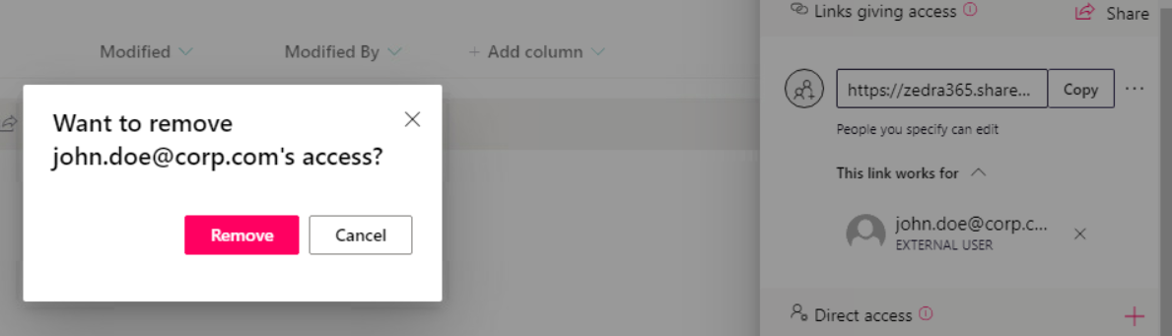

##### **Grant Permissions via Direct Access:**

**! Note: Content Managers** can grant access to Zedra staff by using the **Direct** **Access** option

* + Enter the email address of your Zedra colleague, chose the type of permissions (**Edit** or **View**) and chose if you with to notify the user.
  + After the necessary modifications have been made, select the **Grant Access** button.

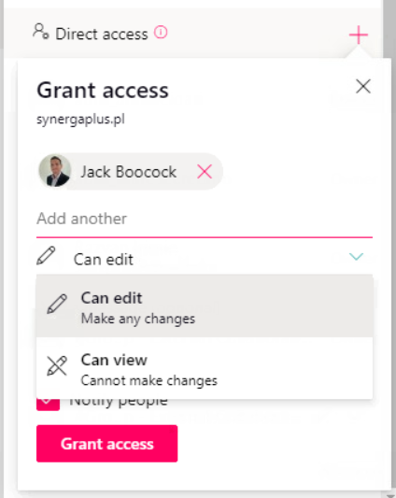

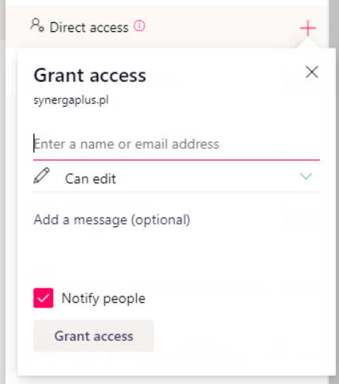

* + Content Managers can also grant permissions to groups of users:

**! Note:** Office 365 groups of users are created by Zedra BST staff. To a request the creation of a group of users, please address these requests to …

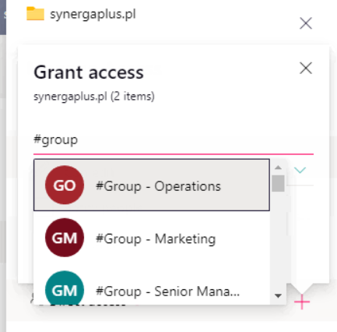

#### MANAGE CONTENT

##### **Upload, Create and Edit Content:**

* Upload documents:

Users and content Managers can **upload** documents or create **Microsoft** **Office** documents directly from the SharePoint Platform, as well as share the content with Zedra staff and outside users.

* Upload files by “dragging” the files from your machine in the **Drag files here** section of the desired folder:

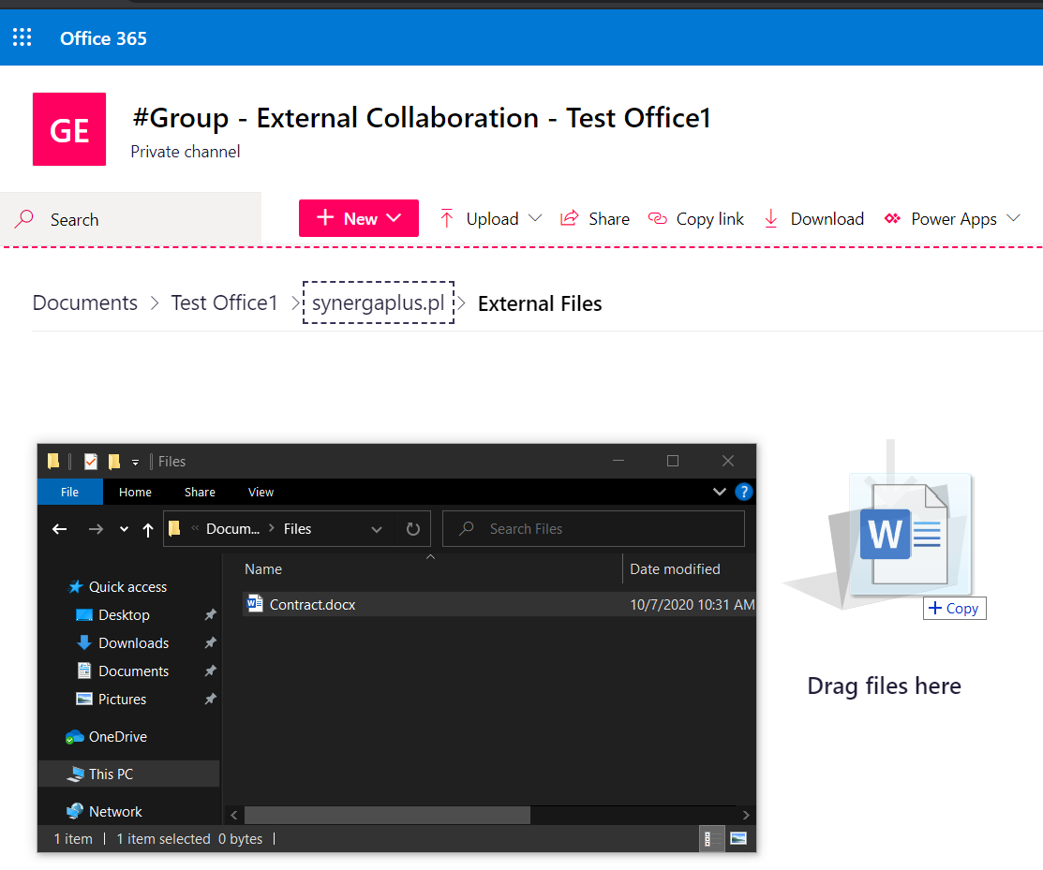

* Upload files by using the **Upload** button:

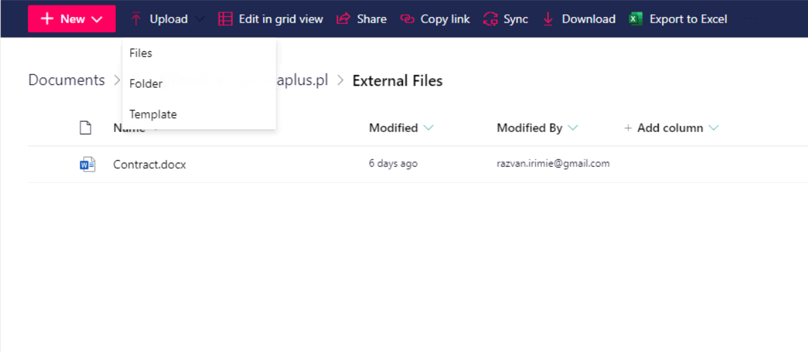

**! Note:** Users can upload individual files or upload entire folders and their contents.

* Create documents:
* (**Optional**)If you need to create a new folder to store the file, select **Folder** from the **New** drop-down list and provide a name for the folder:

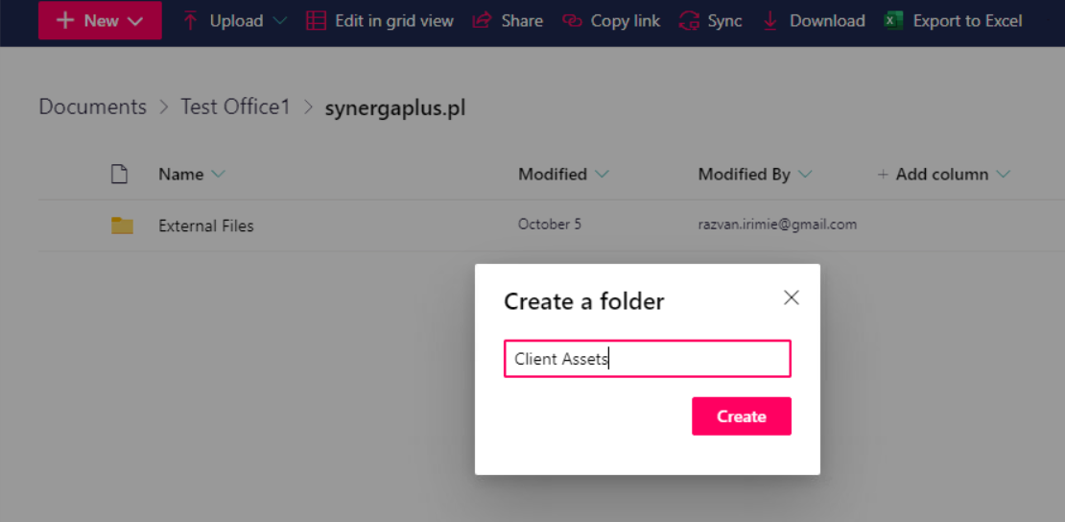

* Go to the location in the document library where you want to create a new file and open the **New** drop-down menu.

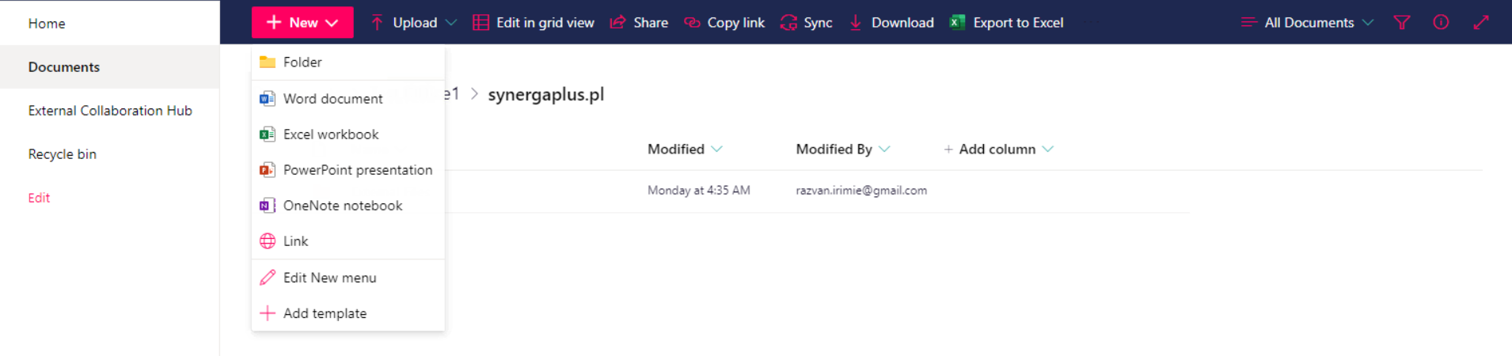

* Select the type of file you want to create.
* A new tab will open with the Web Version of the specific Office App.

* Edit the documents:
  + 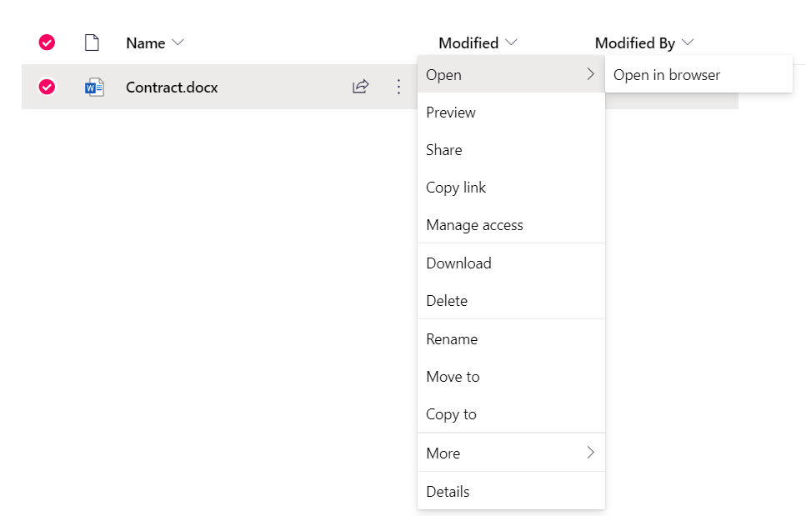Use the “Open in browser” option which will open the document in a new tab, in a Web Version of Microsoft Word. The document is saved automatically after each modification.
  + Download the document, edit it on your device and afterwards upload it back to the platform (see **section 3.1**  for instructions on how to upload content).



**! NOTE:** If the uploaded file has the same name as an already existing file on the platform users ill receive a prompt asking them to confirm if they would like to upload the file as a version of the existing file**.**

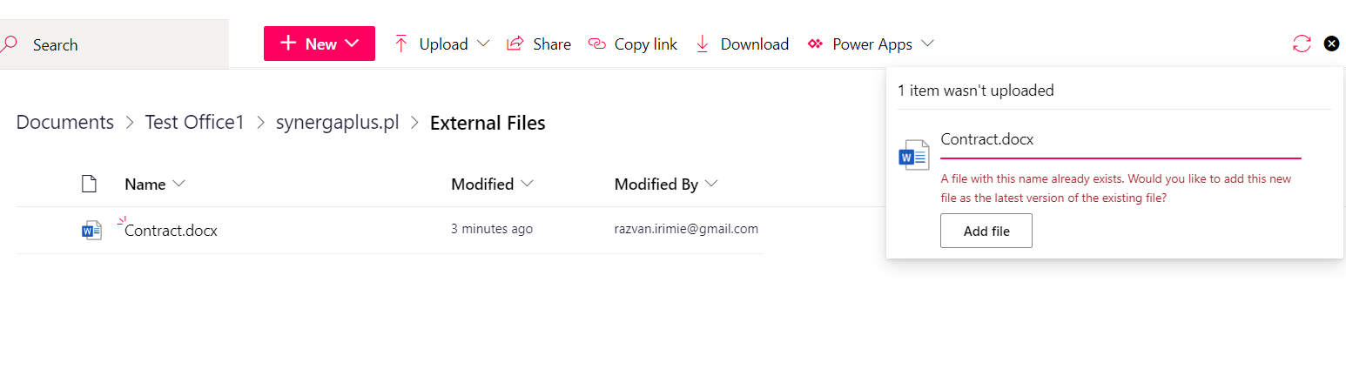

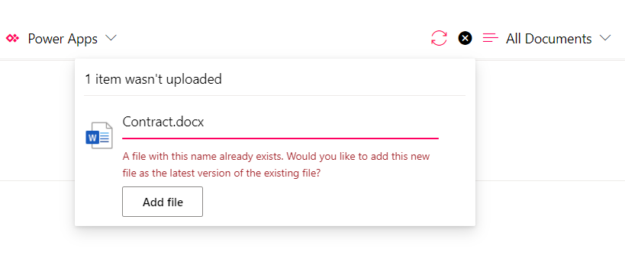

**! NOTE:** Further instructions on how to upload, create and manage files can be found [here](https://support.microsoft.com/en-us/office/create-upload-and-share-files-in-a-document-library-98cb2ff2-c27e-42ea-b055-c2d895f8a5de).

##### **Manage Document Versioning:**

* + SharePoint Online provide the ability to store, track and restore different versions of documents.

**For any further questions or inquiries please contact the Zedra Service Desk via email at** [**Servicedesk@zedra.com**](mailto:servicedesk@zedra.com?subject=External%20Collaboration%20Platform%20Assistance)